**Week 10-01:**

**Name:Snehan.S**

**Roll no:241801272**

1. Input Format You are given two strings, a and b, separated by a new line. Each string will consist of lower-case Latin characters ('a'-'z'). Output Format In the first line print two space-separated integers, representing the length of a and b respectively. In the second line print the string produced by concatenating a and b (a + b). In the third line print two strings separated by a space, a' and b'. a' and b' are the same as a and b, respectively, except that their first characters are swapped.

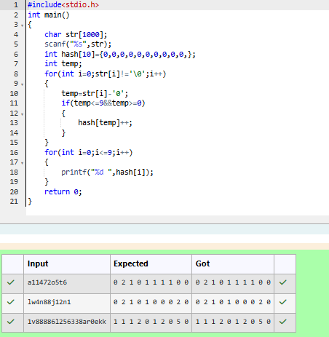

1. Given a sentence, s, print each word of the sentence in a new line.

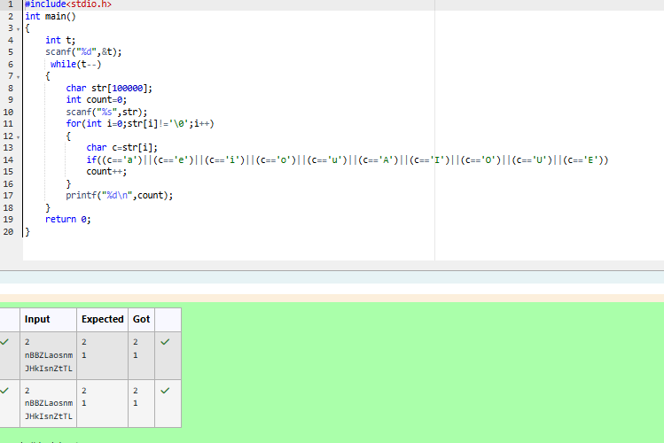

3. Given a string, s, consisting of alphabets and digits, find the frequency of each digit in the given string.

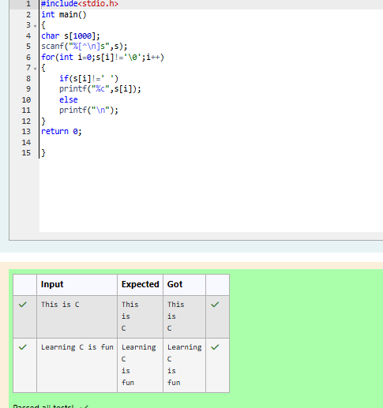

4.Today, Monk went for a walk in a garden. There are many trees in the garden and each tree has an English alphabet on it. While Monk was walking, he noticed that all trees with vowels on it are not in good state. He decided to take care of them. So, he asked you to tell him the count of such trees in the garden. Note: The following letters are vowels: 'A', 'E', 'I', 'O', 'U', 'a', 'e', 'i', 'o' and 'u'

